S3 Bucket Setup
- Open Amazon S3 console
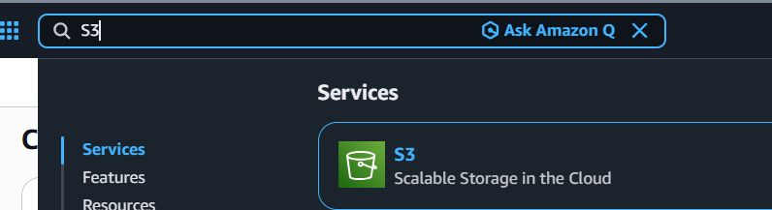

- Click on create bucket
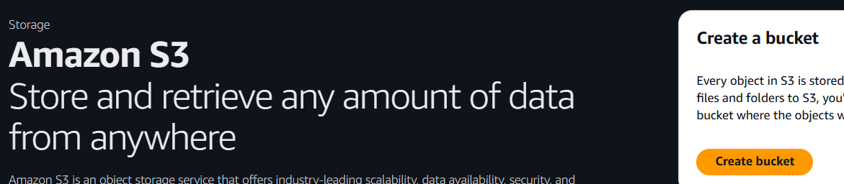

- Name the bucket name as audit-test-bucket-s3
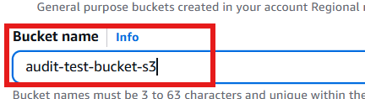

- Default as SSE-S3 and Bucket Key disabled
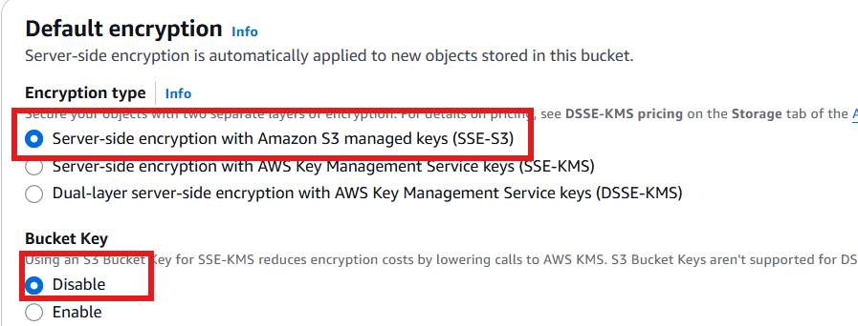

- Click upload to upload a test file
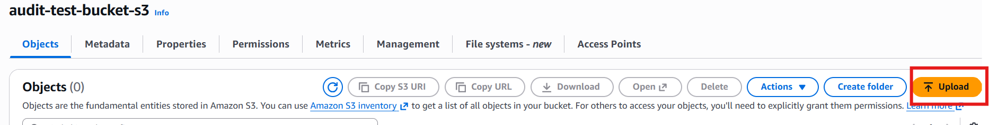

- Click add file to upload a file from local PC.
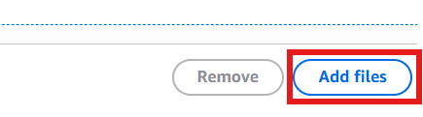

- File has uploaded now in S3 bucket.
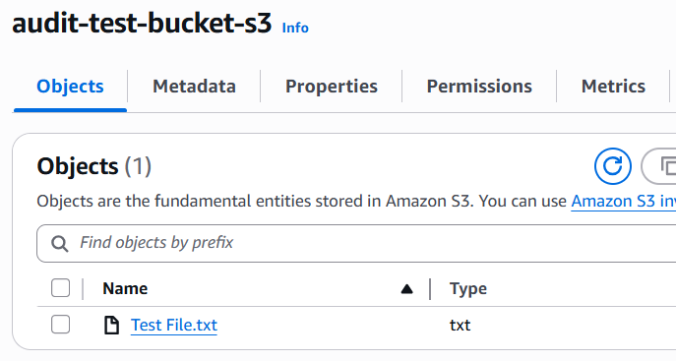

- Create another bucket with name audit-test-bucket-kms for SSE-KMS
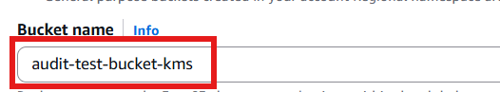

- Default as SSE-KMS, choose and selected available AWS KMS Keys, and Bucket Key disabled
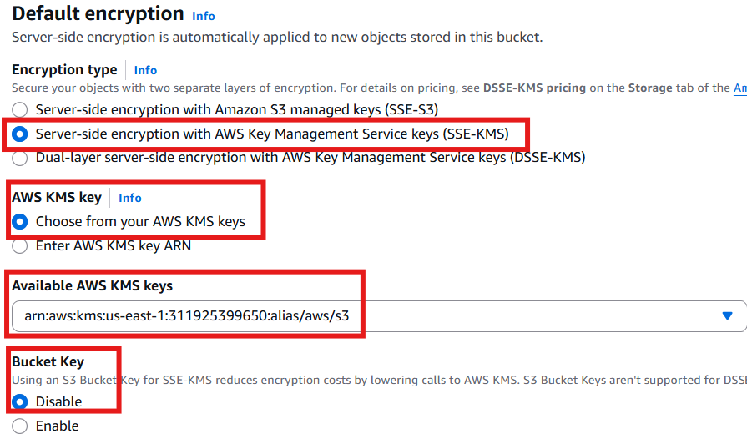

- File uploaded.
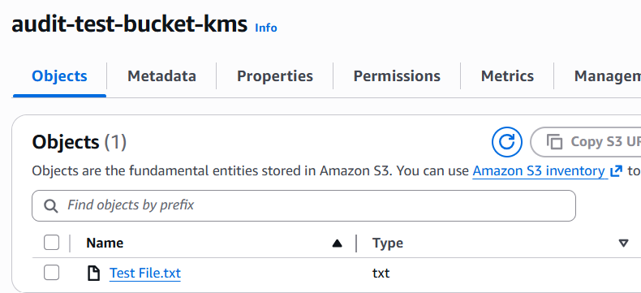

- Created another bucket in the name of audit-test-bucket-unencrypted
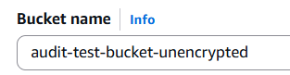

- Totally three buckets were created
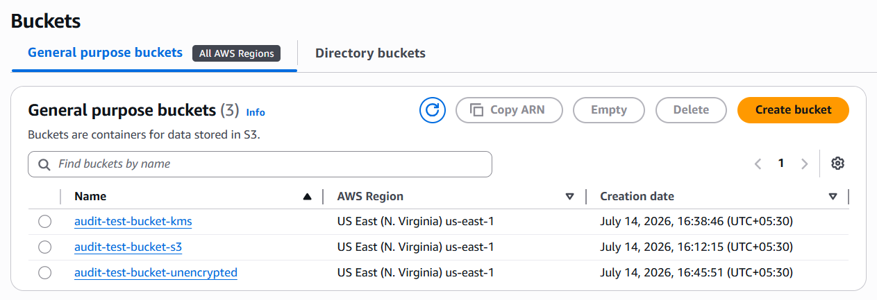

Lambda IAM Role
- Create an IAM execution role for Lambda function. Open IAM console.
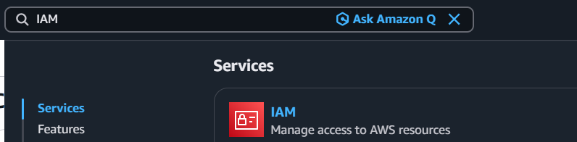
- Adding inline policy as in below.
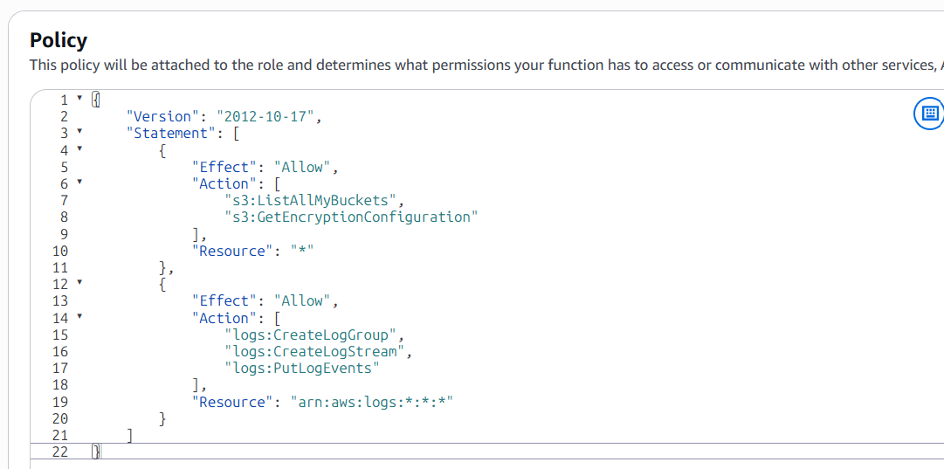

- Name the IAM Role LambdaExecutionRoleForAuditS3
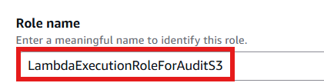

- Inline policy Name will be as in below
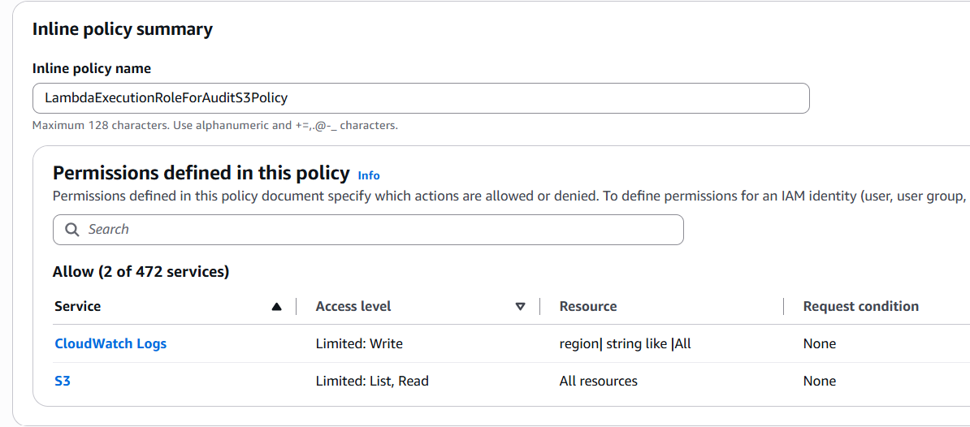

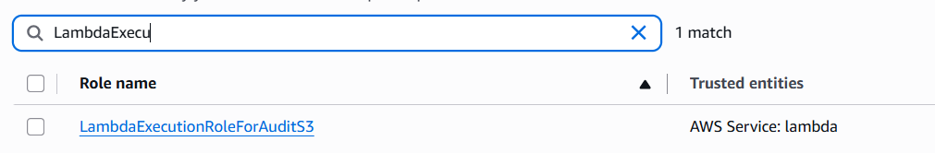

Lambda Function (Boto3)
- Open Lambda console
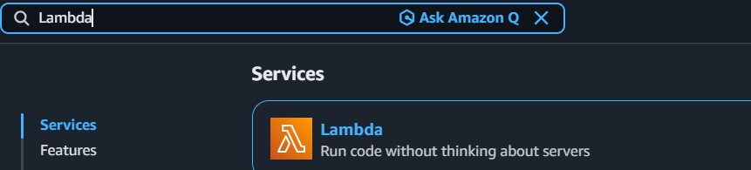
- Create Lambda function with Python latest version
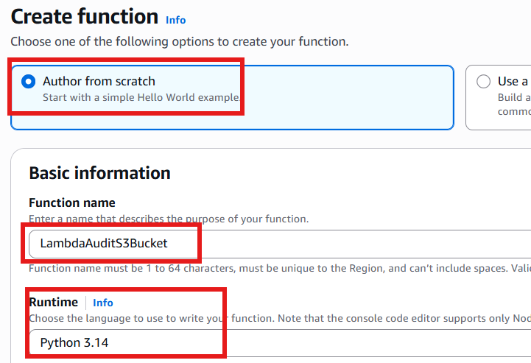

- Coded the below python code on Lambda code.

- import os
- import boto3
- import logging
- from botocore.exceptions import ClientError

- # Set up logging
- logger = logging.getLogger()
- logger.setLevel(logging.INFO)

- s3_client = boto3.client('s3')

- def lambda_handler(event, context):
- try:
- # 1. List all S3 buckets
- response = s3_client.list_buckets()
- buckets = response.get('Buckets', [])

- print("\n=== S3 BUCKET ENCRYPTION AUDIT REPORT ===")
- print(f"{'Bucket Name':<45} | {'Encryption Type':<15} | {'KMS Key ID / Status'}")
- print("-" * 100)

- flagged_count = 0

- # 2. Audit each bucket
- for bucket in buckets:
- bucket_name = bucket['Name']

- try:
- enc_config = s3_client.get_bucket_encryption(Bucket=bucket_name)
- rules = enc_config['ServerSideEncryptionConfiguration']['Rules']

- # Read the encryption algorithm
- algo = rules[0]['ApplyServerSideEncryptionByDefault']['SSEAlgorithm']
- kms_key = rules[0]['ApplyServerSideEncryptionByDefault'].get('KMSMasterKeyId', 'N/A')

- # Determine user-friendly type
- if algo == 'AES256':
- enc_type = "SSE-S3"
- status_flag = "⚠️ [FLAGGED: NOT SSE-KMS]"
- flagged_count += 1
- elif algo == 'aws:kms':
- enc_type = "SSE-KMS"
- status_flag = kms_key
- else:
- enc_type = algo
- status_flag = "⚠️ [UNKNOWN ALGO]"
- flagged_count += 1

- except ClientError as e:
- # Handle buckets with no encryption configuration explicitly set
- if e.response['Error']['Code'] == 'ServerSideEncryptionConfigurationNotFoundError':
- enc_type = "None (Default S3)"
- status_flag = "⚠️ [FLAGGED: NOT SSE-KMS]"
- flagged_count += 1
- else:
- enc_type = "ERROR"
- status_flag = f"❌ Could not retrieve: {e.response['Error']['Message']}"

- # 3. Print report line item
- print(f"{bucket_name:<45} | {enc_type:<15} | {status_flag}")

- print("-" * 100)
- print(f"Audit complete. Total Flagged Buckets (Non-KMS): {flagged_count}\n")

- return {
- 'statusCode': 200,
- 'body': f"Audit completed successfully. Flagged {flagged_count} buckets."
- }

- except Exception as e:
- logger.error(f"Global execution error: {str(e)}")
- return {
- 'statusCode': 500,
- 'body': f"Error executing audit: {str(e)}"
- }

Testing & Verification
- Click Deploy in the Lambda console.
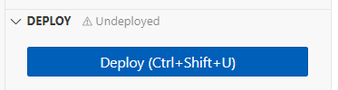
- Click Test and create a dummy test event.
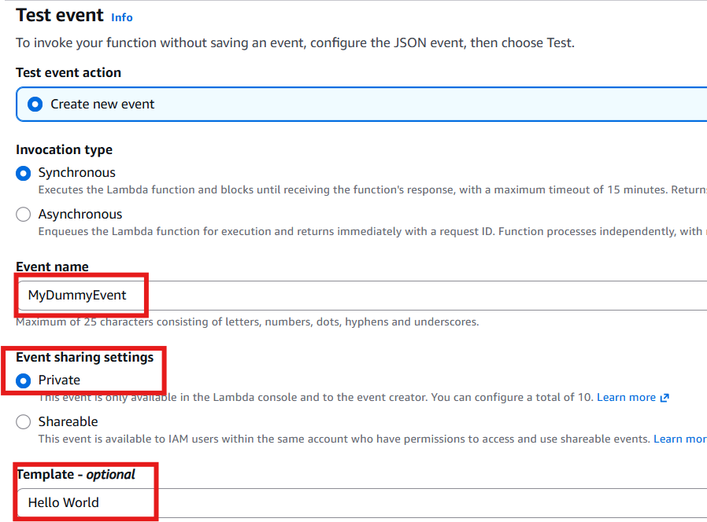
- Event Json as default
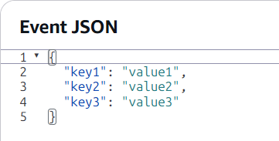
- Click Test again to execute the function manually.
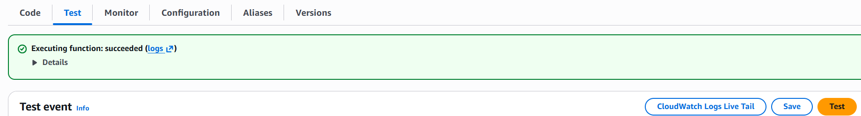
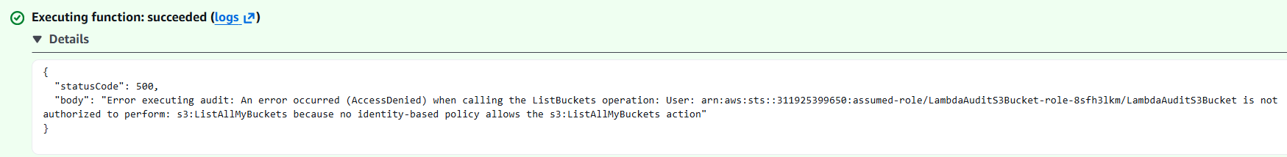

- Navigate to the Monitor tab and click View CloudWatch Logs.
Log groups:
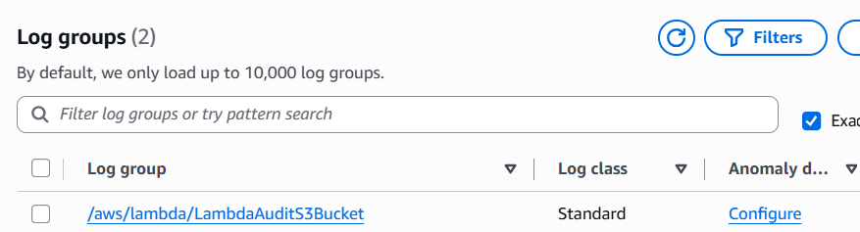
Log stream:
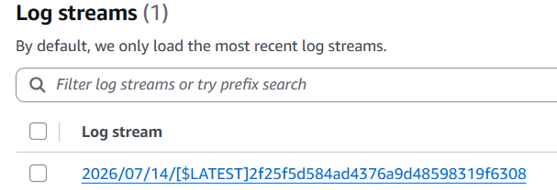
Log Events:
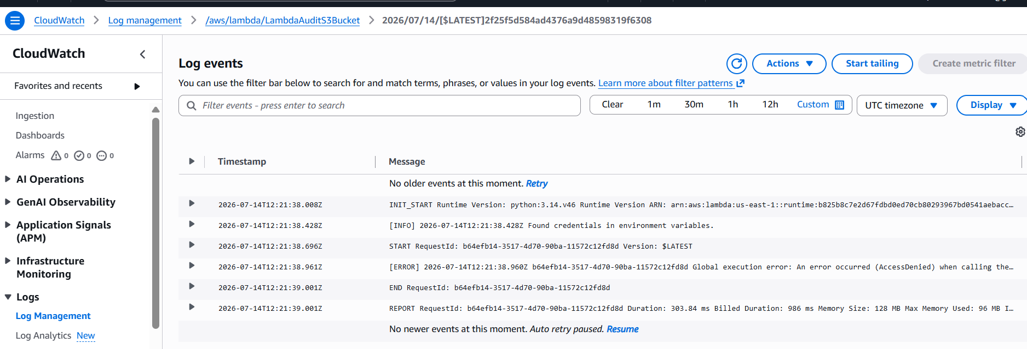

- Getting below error and set the correct execution role policy in Lambda configuration.

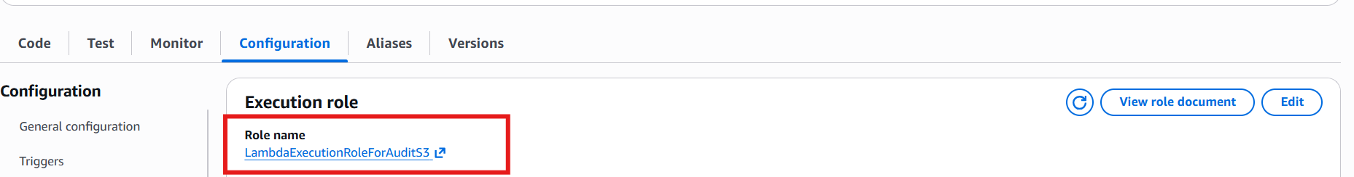
- After I saved the event and test again, I got the below message.
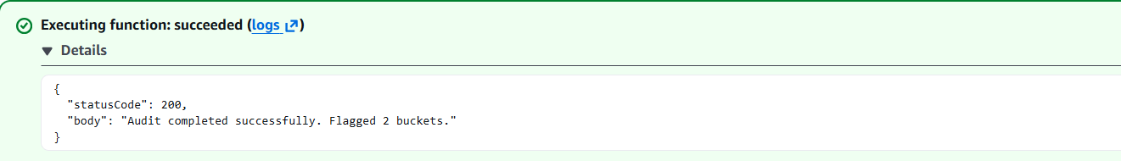

- I can see the Latest log stream
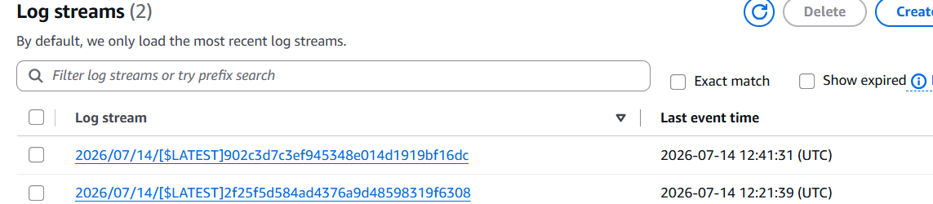

Text
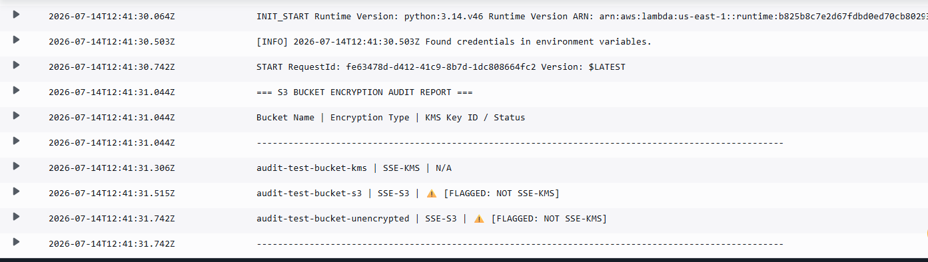
Audit complete. Total Flagged Buckets (Non-KMS): 2

